**<!-- Topic: Assesment on DATABASE.**

**Author: Kathiravan A**

**Created Date: 05.04.2024**

**Last modified date: 07.04.2024**

**Reviewed by:**

**Reviewed date:**

**-->**

**Table 1: programmer**

create table programmer(

name varchar(28),

dob date,

doj date,

sex varchar(1),

prof1 varchar(28),

prof2 varchar(28),

salary int

);

insert into programmer values(‘kathir’, ‘2002-12-29’,‘2024-01-21’,‘m’,’c’,SQL’,3000);

insert intoprogrammervalues(‘bharat’,‘20011022’,‘20240121’,‘m’,’python’,mangodb’,3000);

insert into programmer values(‘ajay’, ‘2002-11-12’,‘2024-01-21’,‘m’,’java’,SQL’,3000);

insert into programmer values(‘balaji’, ‘2003-09-15’,‘2024-01-21’,‘m’,’java’,reactjs’,3000);

insert into programmer values(‘rohan’, ‘2003-09-26’,‘2024-01-21’,‘m’,’c’,dbms’,3000);

insert into programmer values(‘kumar’, ‘2002-06-19’,‘20240121’,‘m’,’python’,’SQL’,3000);

insert into programmer values(‘naveen’, ‘2003-04-30’,‘2024-01-21’,‘m’,’reactjs’,’SQL’,3000);

insert into programmer values(‘shruti’, ‘2001-11-11’,‘2024-01-21’,‘f’,’js’,’SQL’,3000);

insert into programmer values(‘ananya’, ‘2002-01-17’,‘2024-0121’,‘f’,’nodejs’,’SQL’,3000);

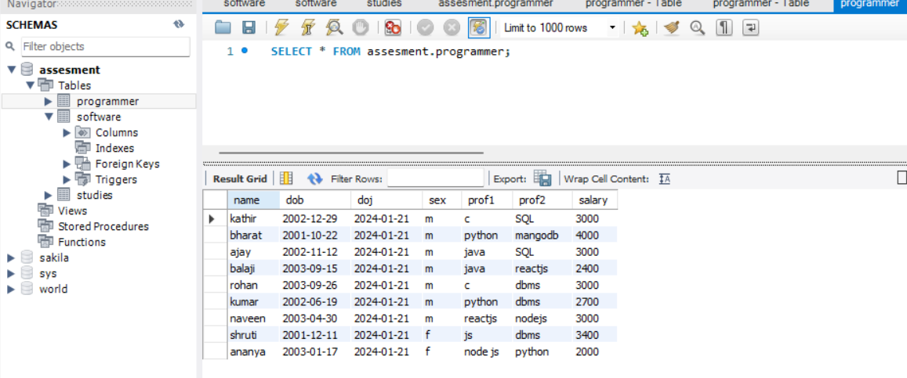

-------------------------------------End of table 1-----------------------------------

**Table 2: software**

Use assessment;

create table software(

name varchar(28),

tittle varchar(220),

devin varchar(20),

scost int,

dcost int

sold int

);

insert into software values('ajay','AI Assistant','python',3000,2700,30);

insert into software values('bala','farm assistant system','reatjs',3300,2800,30);

insert into software values('vishva','encryption od data','python',3700,2900,30);

insert into software values('madhan','weather monitor','java',4000,3700,30);

insert into software values('sharukh','data monitoring system','python',3000,2700,30);

insert into software values('rohith','agri-tech','php',3500,3000,30);

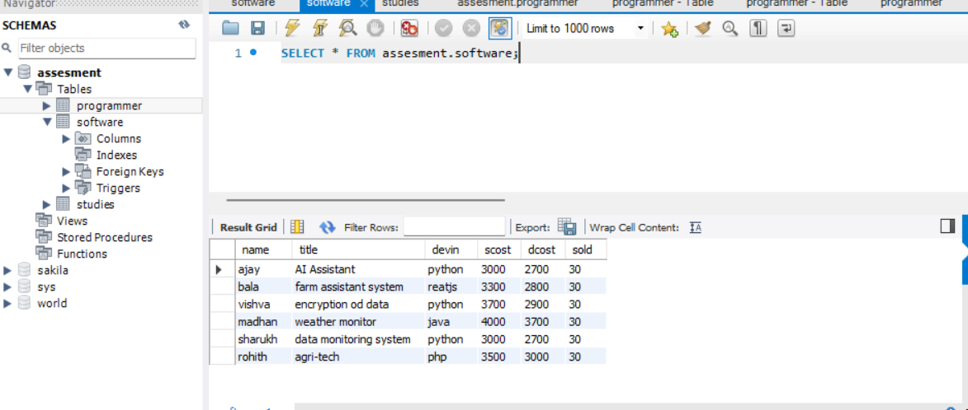

-------------------------------------End of table 2-----------------------------------

**Table 3:studies**

USE assesment;

create table studies(

name varchar(28),

splace varchar(220),

course varchar(20),

cost int

);

insert into studies values('anand', 'villupuram', 'daa' , '20000');

insert into studies values('bala', 'villupuram', 'daa' , '25000');

insert into studies values('chandru', 'chennai', 'php' , '23000');

insert into studies values('deva', 'chennai', 'php' , '27000');

insert into studies values('punith', 'coimbatore', 'java' , '28000');

insert into studies values('saran', 'coimbatore', 'reactjs' , '30000');

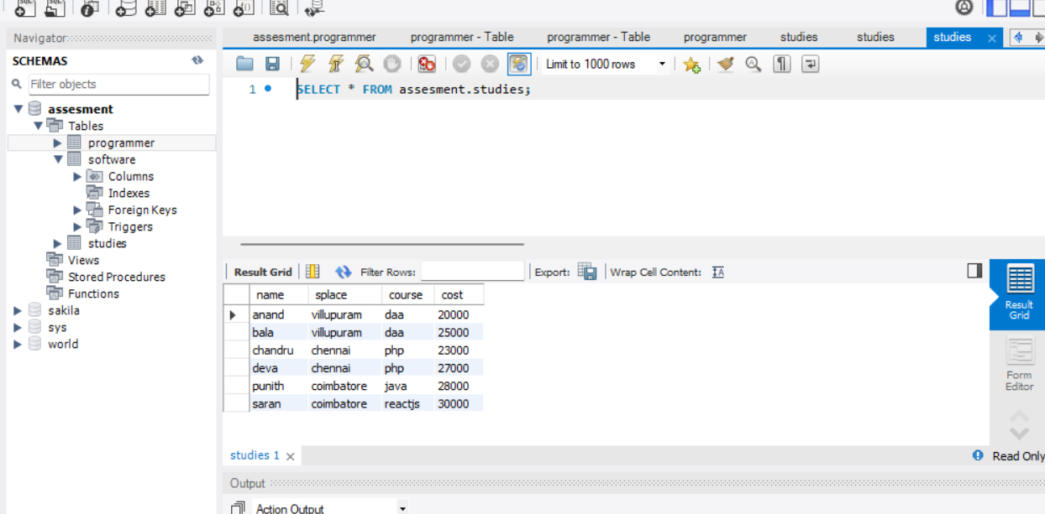

-------------------------------------End of table 3-----------------------------------

1. SELECT avg(scost),devin from software where devin = 'python';
2. D
3. E
4. D
5. D
6. S
7. SELECT count(name),course FROM studies where course='php';
8. SELECT sum(scost),devin FROM assesment.software where devin='python';
9. SELECT title FROM assesment.software where name = 'ajay';
10. SELECT count(name),splace FROM assesment.studies where splace='chennai';
11. select * from software where scost >3000;
12. SELECT count(title) FROM assesment.software where scost > dcost;
13. D
14. SELECT * FROM assesment.software where scost > dcost;
15. SELECT count(title),devin FROM assesment.software where devin = 'python';
16. SELECT count(splace) FROM assesment.studies where splace = 'chennai';
17. SELECT count(name) FROM assesment.studies where cost < 30000 and cost > 24000;
18. SELECT avg(cost) FROM assesment.studies;
19. SELECT * FROM assesment.programmer where prof1 = 'c';
20. SELECT * FROM assesment.programmer where prof1 = 'c' or prof2 = 'dbms';
21. SELECT * FROM assesment.programmer where prof1 not in('c','java');
22. D
23. D
24. D
25. D
26. SELECT count(name) FROM assesment.programmer where sex = 'f';
27. SELECT prof1, prof2 FROM assesment.programmer where sex = 'm';
28. SELECT avg(salary) FROM assesment.programmer;
29. SELECT count(name) FROM assesment.programmer where salary>2500 and salary<3000;
30. SELECT * FROM assesment.programmer where prof1 not in ('c','js','java');
31. F
32. G
33. T
34. F
35. G
36. T
37. SELECT scost FROM assesment.software where name = 'bala';
38. SELECT distinct splace FROM assesment.studies;
39. SELECT count(distinct course) FROM assesment.studies;
40. SELECT * FROM assesment.programmer where name like '%A%A%';
41. SELECT name FROM programmer where length(name) >5;
42. sdas
43. SELECT min(length(name)) FROM programmer;
44. SELECT avg(dcost),devin FROM assesment.software where devin = 'python';
45. d
46. SELECT * FROM programmer WHERE DAY(dob) = DAY(LAST_DAY(dob));
47. SELECT salary FROM assesment.programmer where sex = 'm'and prof1 not in ('c');
48. select title, scost, dcost, scost-dcost as difference from software order by difference desc;
49. SELECT name,dob,doj FROM programmer having month(dob) = month(doj);
50. SELECT title from software where length(length(name)-length(replace(name,' ',''))) >1;---------------------(total length of words – total length of words after removing spaces)---------

Part-II

1. SELECT devin, COUNT(title) AS numberofLanguage from software GROUP BY devin ;
2. SELECT name, COUNT(title) AS developedProject from software GROUP BY name ;
3. SELECT sex, count(name) AS NoOfEmployees from programmer group by sex;
4. select max(scost),devin from software group by devin;
5. select count(name),year(dob) from programmer group by year(dob);
6. select count(name),year(doj) from programmer group by year(doj);
7. select count(name),month(dob) from programmer group by month(dob);
8. select count(name),month(doj) from programmer group by month(doj);
9. SELECT count(name),prof1 from programmer group by prof1;
10. SELECT count(name),prof2 from programmer group by prof2;
11. SELECT count(name),salary from programmer group by salary;
12. select count(name), splace from studies group by splace;
13. select count(name), course from studies group by course
14. select sum(dcost), devin from software group by devin;
15. select sum(scost), devin from software group by devin;
16. s
17. s
18. select count(title),name from software group by name;
19. SELECT name,max(scost),title from assesment.software group by title,name;
20. SELECT name,max(salary) from assesment.programmer group by name; , SELECT name,min(salary) from assesment.programmer group by name;
21. SELECT name,avg(scost),avg(dcost) from assesment.software group by name;
22. SELECT count(course),course,avg(cost) FROM assesment.studies group by course
23. SELECT count(name),splace FROM assesment.studies group by splace
24. SELECT count(name),sex from assesment.programmer group by sex;
25. SELECT name,salary from assesment.programmer;
26. select count(salary),prof1 as languages from assesment.programmer group by prof1, prof2;
27. SELECT devin,count(sold) as projectSold FROM assesment.software where dcost < 3000 group by devin;
28. SELECT avg(scost)-avg(dcost) as Difference,devin from assesment.software group by devin;
29. Need to be asked
30. SELECT max(salary) as highest_salary,min(salary) as lowest_salary,avg(salary) FROM assesment.programmer where salary > 3000;

Part – III

1. SELECT max(salary) as MAX_salary,prof1 FROM assesment.programmer where prof1='c' group by prof1;
2. Need to be asked
3. SELECT max(salary) as MAX_salary,prof1 FROM assesment.programmer group by prof1;
4. Need to be read
5. Need to be read
6. SELECT prof2 FROM assesment.programmer GROUP BY prof2 HAVING COUNT(*) = 1;
7. SELECT name,doj FROM assesment.programmer WHERE doj = (SELECT MIN(doj) FROM assesment.programmer);-------------using limit method and join,null
8. select count(name) as number_of_students ,splace from assesment.studies group by splace ;-------------------------need to be discussed
9. need to be asked
10. SELECT name FROM assesment.programmer where salary>2000 and sex= 'f' and prof1 <> 'python''node js';
11. SELECT course,cost FROM assesment.studies where cost = (select max(cost) from assesment.studies);
12. ct count(name)/count(name) as count from assesment.studies);
13. select avg(name),splace from assesment.studies where name < (select count(name)/count(name) as count from assesment.studies) group by splace;
14. select course,cost from assesment.studies where cost < (select avg(cost) as Average_fee from assesment.studies) or cost > cost < (select avg(cost) as Average_fee from assesment.studies)
15. select title from assesment.software where dcost = (select max(dcost) from assesment.software)
16. select title from assesment.software where scost = (select min(scost) from assesment.software)
17. select name,sold from software where sold = (select min(sold) from software);
18. select devin, scost from software where scost = (select max(scost) from software)
19. need to study
20. select title,dcost from software where devin = 'java' and dcost= (select max(dcost) from software);
21. select devin,sold from software where sold= (select max(sold) from software);
22. select name,sold from software where sold= (select max(sold) from software);
23. select name,scost from software where scost= (select max(scost) from software);
24. select title,sold from software where sold< (select avg(sold) from software);
25. SELECT name,salary FROM programmer where salary > (select max(salary) from programmer where sex = 'm') and sex='f';
26. S
27. Need to be asked
28. Need to be asked
29. Need to be asked
30. Need to be asked
31. Need to be asked
32. Need to be asked
33. Need to be asked
34. Need to be asked
35. select name,salary from programmer where sex='m' and salary < (select avg(salary) from programmer where sex = 'f');

PART -IV

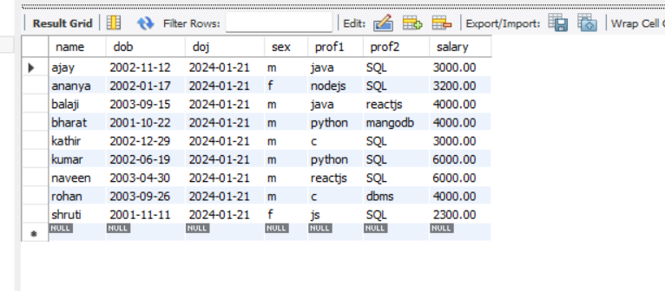

Table 1 programmer

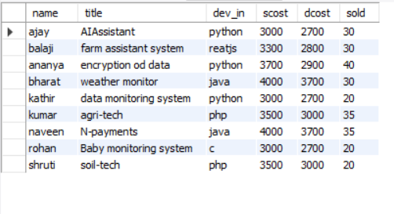

Table 2 : software

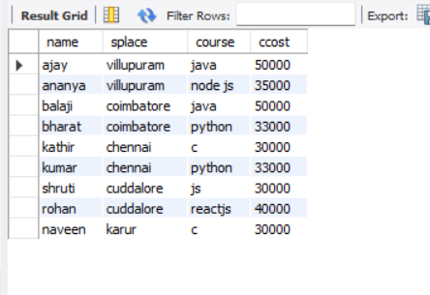

Table 3: studies

1. select * from programmer where salary in (select salary from programmer group by salary having count(*) > 1);

2. select * from programmer where sex="Male" and salary>3000;

3. SELECT * FROM programmer where sex = 'f' and prof1 = 'java';

4. select year(doj) from programmer where year(doj)>2005;

5. need to clarify